Glen (Lake) Wolfe
January 8, 1900 – June 16, 1930

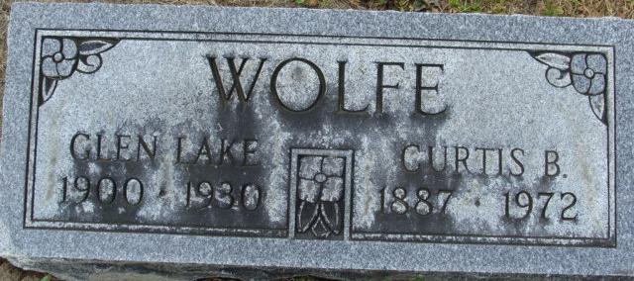
Photo by Alicia Kneuss

Mrs Glenn Wolfe
in the Indiana, U.S., Death Certificates, 1899-2017
Name Mrs Glenn Wolfe
[Mrs Glenn Lake]
Gender Female
Race White
Marital Status Married
Age 30
Birth Date 8 Jan 1900
Birth Place Indiana
Death Date 16 Jun 1930
Death Place Fort Wayne, Allen, Indiana, USA
Death Registration Date 1930
Father Leon D. Lake
Mother Etta Foughty
Informant Leon D. Lake; Decatur, Indiana
Burial June 18, 1930; Decatur, Indiana

