Dorothy (Combs) Wolfe
August 12, 1938 – June 13, 2023

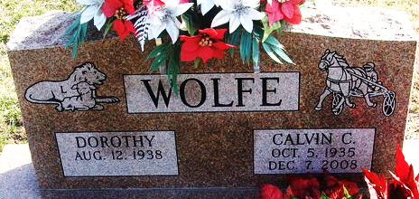
Photo by Alicia Kneuss

Dorothy (Combs) Wolfe, 84, of Decatur, Indiana passed away Tuesday afternoon, June 13, 2023, at Ossian Healthcare & Rehabilitation. She was born August 12, 1938 in London, Kentucky to Ballard and Fannie Elizabeth (Hodge) Combs. Dorothy was united in marriage to Calvin C. Wolfe on October 27, 1956 in Decatur, Indiana and he preceded her in death on December 7, 2008.
She attended The Bridge Community Church in Decatur and had worked in the nursery at the church for several years. Dorothy worked at General Electric in Fort Wayne for 34 years before retiring in 1996. After retirement, at the age of 65, Dorothy received her GED. She loved her kids, grandkids and great-grandkids greatly. She was a hard worker her entire life and could work circles around everyone. She loved reading and doing crossword puzzles.
She is survived by five daughters, Teresa Sue (Philip) Scare of Waterloo, South Carolina, Tina Lou (Vern) Peterson of Decatur, Indiana, Tamara Jo (Greg) Wright of Portland, Indiana, Tonya Jill (Dennis) Sudduth of Decatur, Indiana, Twyla G. Wolfe, Decatur, Indiana; 15 grandchildren, Trisha (George) Herold, Krissy (Trevor) Kuntz, Curtis Peterson, Casey Peterson, Matthew (Jennifer) Billington, Mischele (Jason) Denniston, Zach (Candy) Wright, Chandra (Rhett) Chapman, Roxie (Ronnie) Barron, Sarah (Dan) Sudduth, Nathanael (Patrick) Sudduth, Justin Strader, Wyatt “Hawk” Strader, Dakota (fiancé, Savannah McClure) Strader, Joel Wolfe, and Lily Wolfe; 22 great-grandchildren; one great-great-grandchild.
She was preceded in death by a granddaughter, Tara Scare; four brothers, Harvey, John, Dallas & Jesse Combs; and seven sisters, Suda Young, Zola Clark, Ruth Peters, Ida Lou Danels, Juanita Campos, Marie Hutzell and Ruby Ogg.
A memorial service will be held at 1:00 p.m. Sunday, June 25, 2023, at Zwick & Jahn Funeral Home in Decatur with Pastor Dave Fox officiating. Family and friends will be received from 11:00 a.m. to 1 p.m. Sunday, June 25, 2023, at Zwick & Jahn Funeral Home in Decatur.
Preferred memorials are to The Bridge Community Church or Heart to Heart Hospice.
Zwick & Jahn Funeral Home, Adams County, Indiana
June 14, 2023

