Curtis Brooks Wolfe
February 9, 1887 – September 27, 1972

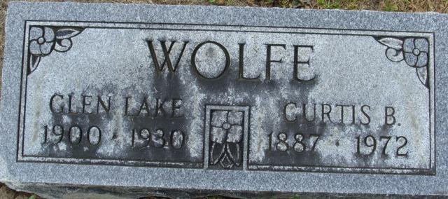
Photo by Alicia Kneuss

Curtis B. Wolfe Dies at Hospital
Curtis Brooks Wolfe, 85, of 950 High Street, died at 9:30 p.m. Wednesday at the Adams County Memorial Hospital. He had been in failing health for the past three months. Mr. Wolfe was a general contractor and retired in 1952.
He was born in Adams County Feb. 9, 1887, and was married to the former Glenn Lake. Mrs. Wolfe died June 16, 1930.
Survivors include one son, Don Wolfe, Decatur; one stepson, William Ayres, Fort Wayne; three grandchildren, Mrs. David (Donna) Kitson, Decatur; Kenneth Wolfe, Decatur; and Brooks Wolfe, Decatur; two great-grandchildren, Marci and Leiah Kitson. Two sisters and two brothers preceded him in death.
Funeral services will be held at 2 p.m. Friday at the Zwick Funeral Home, with Rev. Joseph Gibson officiating. Burial will be in the Decatur Cemetery. Friends may call at the funeral home after 7 p.m. tonight.

Decatur Daily Democrat, Adams County, Indiana
Thursday, September 28, 1972
**
Indiana, U.S., Death Certificates, 1899-2011
Name: Curtis Brooks Wolfe
Gender: Male
Race: White
Age: 85
Marital status: Widowed
Birth Date: 9 Feb 1887
Birth Place: Indiana
Death Date: 27 Sep 1972
Death Place: Decatur, Adams, Indiana, USA
Parents: Unknown
Informant: Don Wolfe; son; Decatur, Indiana
Burial: September 29, 1972; Decatur Cemetery; Decatur, Indiana

