Cleo L. (Chadwell) Wolfe
July 30, 1926 – January 8, 2016

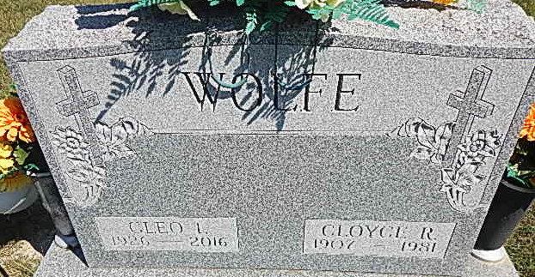
Photo by Alicia Kneuss

Cleo L. Wolfe, 89, of Decatur, IN, passed away on Friday, January 8, 2016 at Adams Memorial Hospital. She was born on July 30, 1926 in Richmond, Kentucky to the late Edgar W. and Nettie (Rollins) Chadwell.
Cleo was a member of First United Methodist Church. She worked as a glass cutter for Duo Marine (Thunderbird). She also was a hostess at Country Farms and The Galley. She loved her family, they were her life.
She is survived by 3 sons, Dan L. (Diane) Putteet of Lavonia, GA; Doug W. (Beth) Putteet and Ron A. (Tammy) Putteet both of Decatur; a brother, David Chadwell of Decatur; 14 grandchildren and 17 great grandchildren.
She was preceded in death by her husbands, Roscoe Putteet and Cloyce Wolfe and 3 sons, Willie E. and Charles A. Putteet and Paul W. Hodge.
Visitation will be from 5:00 - 8:00 p.m. on Tuesday, January 12, 2016 at Haggard-Sefton & Hirschy Funeral Home. A Funeral Service will be held at 10:00 a.m. on Wednesday, January 13, 2016 also at the funeral home. Pastor Harold Klinker will be officiating and burial will take place in the Decatur Cemetery.
In lieu of flowers, memorials may be made to the A.C.C.F. Angel Cancer Fund.

Haggard & Sefton Funeral Home, Adams County, Indiana
January 9, 2016

