Calvin Curtis Wolfe
October 5, 1934 – December 7, 2008

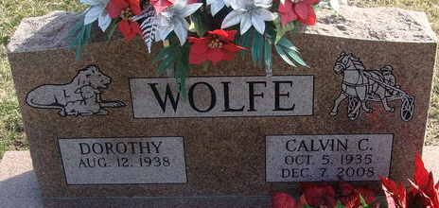
Photo by Alicia Kneuss

Calvin Curtis Wolfe, 73, Pleasant Mills, the father of a Portland woman, died Sunday at his home. Born in Adams County to Carl O. and Beatrice (Roush) Wolfe, he was married to Dorothy Combs, who survives.
Others surviving are five daughters, including Mrs. Greg (Tamara) Wright, Portland; three brothers; four sisters; 15 grandchildren and five great-grandchildren.
Services are Friday at 1 p.m. at Zwick and Jahn Funeral Home in Decatur. Burial will be in Decatur Cemetery. Visitation is Thursday from 2 to 4 and 5 to 8 p.m. at the funeral home.
Memorials may be sent to The Bridge Church or Adams County Community Foundation-Cancer Fund.

Commercial Review, Jay County, Indiana
Wednesday, December 10, 2008

**
Indiana, U.S., Death Certificates, 1899-2017
Name Calvin Curtis Wolfe
Gender Male
Race White
Marital Status Married
Age 73
Birth Date 5 Oct 1935
Birth Place Adams County, Indiana
Death Date 7 Dec 2008
Death Place Pleasant Mills, Adams, Indiana, USA
Death Registration Date 2008
Father Carl O Wolfe
Mother Beatrice Roush
Spouse Dorothy Combs
Informant Dorothy Wolfe; wife; Pleasant Mills, Indiana
Burial Decatur Cemetery; Decatur, Indiana

