Bertha Belle (Bailey) Wolfe
October 1, 1905 – September 3, 1976

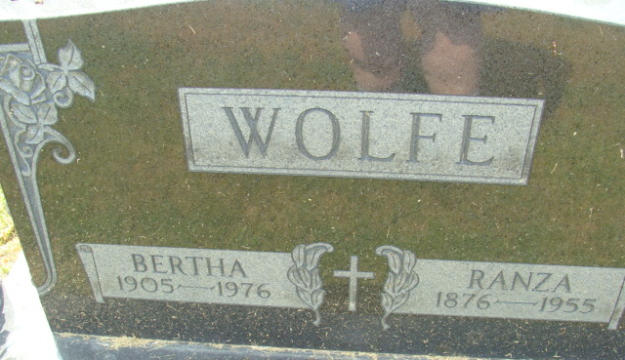
Photo by Alicia Kneuss

Bertha Belle Wolfe
in the Indiana, U.S., Death Certificates, 1899-2017
Bertha Belle Wolfe
[Bertha Belle Bailey]
Gender Female
Race White
Marital Status Widowed
Age 70
Birth Date 1 Oct 1905
Birth Place Indiana
Death Date 3 Sep 1976
Death Place Fort Wayne, Allen, Indiana, USA
Death Registration Date 1976
Father Peter Bailey
Mother Mamie Uhrick
Informant Merlin O. Wolfe; son; New Haven, Indiana
Burial September 5, 1976; Decatur Cemetery; Decatur, Indiana

