Charleen Louise (Feasel) Wolfe-Allison
January 20, 1943 -

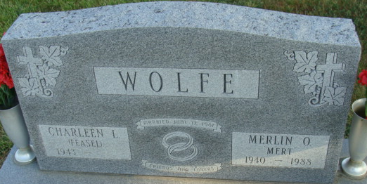
Photo by Alicia Kneuss

Charleen Louise Feasel
in the Indiana, U.S., Birth Certificates, 1907-1944
Name Charleen Louise Feasel
Gender Female
Birth Date 20 Jan 1943
Birth Place Decatur, Adams, Indiana, USA
Father Charles Gideon Feasel; age 22
Mother Betty Louise Foughty; age 19; 1st child
Registration Year 1943
Certificate Number 6124
Roll number 60871.IDX.002_I1415138
Volume Range 11-15
**
Indiana, U.S., Marriage Certificates, 1960-2012
Name Charleen L Wolfe
[Charleen L Feasel]
Gender Female
Marriage Age 54
Birth Date abt 1943
Birth Place Indiana
Marriage Date 12 Sep 1997
Marriage Place Lyons, Steuben, Indiana, USA
Marriage Registration Date 1997
Father Charles Feasel
Mother Betty Feasel
Spouse Nolan E Allison
Description St. Joseph-Hamilton
Notes 2 N; Reference Number 1 Bx1450
Reference Number 2 Tr8506
Certificate Number 36661
Box Number Box 5h

