Sylvester Wolf
September 24, 1817 – March 1, 1904

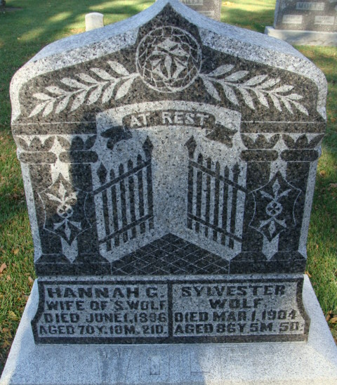
Photo by Alicia Kneuss

Sylvester Wolf
in the Indiana, U.S., Death Certificates, 1899-2017
Name Sylvester Wolf
Gender Male
Race White
Marital Status Widowed
Age 86
Birth Date 24 Sep 1817
Birth Place Ashland County, Ohio
Death Date 1 Mar 1904
Death Place Decatur, Adams, Indiana, USA
Death Registration Date 1904
Father Isaac Wolf
Mother Unknown
Spouse Hannah G
Informant A. R. Wolf; Decatur, Indiana
Burial March 3, 1904; Maplewood Cemetery
**
Sylvester Wolfe from tree Samuel Seymour King
Record information.
Birth 24 (or 26) Sep 1817 Pennsylvania, USA
Marriage 8 Sep 1842 Ohio, USA
Residence 1900 Adams, Indiana, USA
Death 1 Mar 1904 Adams, Indiana, USA
Record information.
Father Isaac Wolfe (1789-1840)
Mother Nancy Schmahl (1796-1879)
Spouse Hannah G Gladden (1825-1896)
**
SYLVESTER WOLF, farmer, section 12, Root Township, Adams County, was born September 24, 1817, and when a year and a half old was taken by his parents to Richland County, Ohio, where he grew to manhood, and where he was married, September 8, 1842, to Hannah Gladden. She was born in Jefferson County, Ohio, and when six months old her parents brought her to Richland County, where she grew to maturity. Her parents were James and Jemima (Jennings) Gladden. Her father was born in Jefferson County, Ohio, in 1795, and her mother in Jefferson County, Ohio, in 1810. They were reared at their birthplace. She married James Gladden, who had five children. Mr. and Mrs. Gladden had twelve children, of whom Mrs. Wolf was the oldest. Eight of the children are living, and the mother died March 10, 1887, in Ashland County, Ohio, where the father died May, 1863. Mr. Wolf was the son of Isaac and Nancy (Small) Wolf. The father was born in Beaver County, Pennsylvania, April 30, 1789, where he was reared and married, and where three children were born. They removed to Richland, Ohio, in 1819, where the father died in 1840, at the age of fifty-one years. He served in the War of 1812 nine months, for which his wife received a pension after his death. The mother was born February 20, 1796, also in Beaver County, Pennsylvania, where she was reared. She died in Ashland County, Ohio, January 9, 1879, aged eighty-one years. After the marriage of Mr. Wolf he lived in Ashland County until 1852, when he came with his wife and four children and settled upon his present farm in Root Township. Not a stick had been cut on the place nor a house built. They stopped with Hiram Gladden until a cabin could be built, into which they moved and commenced to make a home. He lived in this round-log house, by adding a frame apartment, until he built his present house in 1871. He now has a good house and barn, and other farm buildings. Mr. and Mrs. Wolf have nine children - Margaret C., born August 9, 1842; Sarah J., born March 25, 1846; Adamson R., born December 9, 1847; Isaac O., born January 4, 1850, died September 8 of the same year; Oliver C., born August 7, 1851; Martha E., born April 23, 1854; Laura A. E., born October 15, 1858; Ida I., born Mary 3, 1862; Mary E., born April 20, 1864. The five oldest were born in Ashland County, Ohio, and the others in Root Township, Adams County, Indiana. Mr. Wolf has served as school director for many years. In his father's family were ten children, of whom our subject was the third child. His paternal grandfather, John Wolf, was a native of Germany, and died in Beaver County, Pennsylvania. His paternal grandmother, Christena (Guy) Wolf, was a native of Holland, and was twice married, being a widow (Mrs. Myers) with two children when she married Mr. Wolf. By her second marriage she had seven children, Isaac being one of the younger. His maternal grandparents died in Southern Indiana.

Biographical and Historical Record - Adams and Wells Co. Indiana Lewis Publishing Co. Chicago, IL 1887

