Howard O. Wolf
May 23, 1936 – November 17, 2011

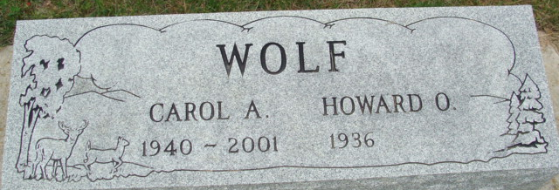
Photo by Alicia Kneuss

Howard O. Wolf, 75, of Decatur, IN passed away on Wednesday, November 17, 2011 at Lutheran Hospital. Howard was born on May 23, 1936 in Fort Wayne, Indiana to the late Otto and Velma (Bevelhymer) Wolf. He married Carol A. Welty on December 14, 1963. She preceded him in death on February 11, 2001.
Howard was a member of the Plymouth Congregational Church in Fort Wayne. He retired in 1997 from Navistar. He was also a member of the American Legion Post #43.
Survivors are a daughter Connie A. (Terry W.) Brandt of Decatur; a brother William Wolf of Illinois and four grandchildren Courtney Wolf, Christopher Wolf, Tracy Brandt all of Ft. Wayne and Shelby Brandt of Decatur. Howard was also preceded in death by a son Ken.
Calling will be Noon-3:00 p.m. on Sunday, November 20, 2011 at Haggard-Sefton and Hirschy Funeral Home. Funeral service will be at 11:00 a.m. on Monday, November 21, 2011 at the funeral home. Rev. John P. Gardner will be officiating and burial will be in Decatur Cemetery. Military Graveside Rites by American Legion Post 43 Colored Guard.
Memorials are to A.C.C.F. Angel Cancer Fund.

Haggard & Sefton Funeral Home, Adams County, Indiana
November 18, 2011

