Hannah (Gladden) Wolf
July 11, 1825 – June 1, 1896

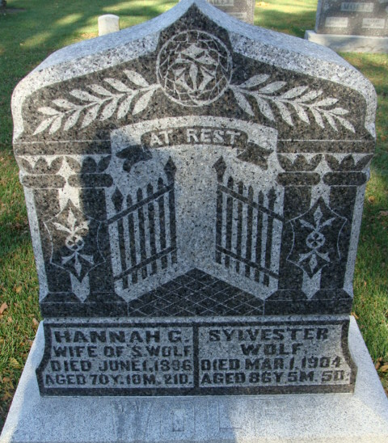
Photo by Alicia Kneuss

Grandma Wolf, aged mother of Mrs. J. Sweaney, of this city, died at the family residence in Adams County, Monday morning last after months of illness. The deceased reached the age of 70 years, 10 months, and 21 days and was one of the oldest and best-known citizens of Adams County and had many relatives and friends in this section.
The funeral was held Wednesday from the house, services at the Baptist church in Decatur and the remains were interred in the Maple Cemetery in Decatur.
The Monroeville Breeze; Allen County, Indiana
June 4, 1896
**
Hannah G Gladden from tree CARROLL / CLARK Family Tree
Birth 11 Jul 1825 Jefferson, Ashtabula, Ohio, USA
Marriage 12 Mar 1846 Belmont, Belmont, Ohio, USA
Residence 1880 Adams, Indiana, USA
Death 1 Jun 1896 Adams, Indiana, USA
Father James Gladden (1794-1863)
Mother Jemima E Jennings (1809-1887)
Spouse William Gladden

