Michael Wittwer
December 29, 1939 – August 20, 2018

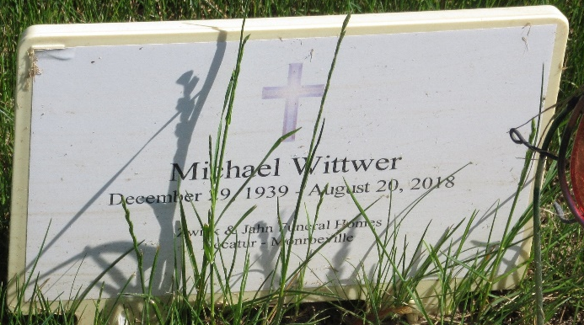
Photo by PLS

Michael Wittwer, 78, of Decatur, Indiana passed away Monday evening, August 20, 2018 at Visiting Nurse & Hospice Home in Fort Wayne. He was born on December 29, 1939 in Adams County, Indiana to Vilas N. & Hilda M. (Haugk) Wittwer. They both preceded him in death.
Mike served his country in the United States Army Reserves.
He was a member of Zion Lutheran Church in Decatur; American Legion Post #43 in Decatur; and the Indiana Volunteer Fire Department Association. He was a longtime member of the Decatur Volunteer Fire Department. Mike had worked at Fleming Excavating for many years as a truck driver and prior to that at Central Soya.
Burial will follow at Decatur Cemetery.

Unknown source

