Hilda M. (Haugk) Wittwer
May 25, 1905 – June 3, 1993

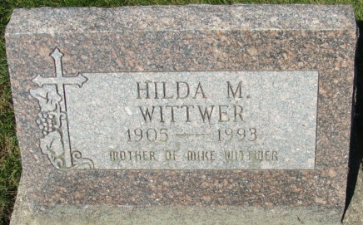
Photo by Alicia Kneuss

Hilda M. Wittwer, 88, of Decatur died Thursday at Parkview Memorial Hospital, Fort Wayne. An Adams County native, she worked in several residential homes. Her husband, Vilas N., died in 1977.
Surviving is her son, Michael of Decatur.
Calling will be 2 to 5 and 7 to 9 p.m. today and 10 a.m to noon tomorrow at Zwick-Sefton & Jahn Funeral Home. Calling will also be 12:30 to 1:30 p.m. tomorrow at Zion Lutheran Church, with services following. Burial will be in Decatur Cemetery.
Preferred memorials are gifts to the Lutheran Hour or the Zion Memorial Fund.

News-Sentinel, Allen County, Indiana
Saturday, June 5, 1993
**
Indiana, U.S., Death Certificates, 1899-2017
Name Hilda M Wittwer
[Hilda M Haugk]
Gender Female
Race White
Marital Status Widowed
Age 88
Birth Date 25 May 1905
Birth Place Root Township
Death Date 3 Jun 1993
Death Place Fort Wayne, Allen, Indiana, USA
Death Registration Date 1993
Father Julius Haugk
Mother Louise Kiefer
Informant Michael Wittwer; son; Decatur, Indiana
Burial June 6, 1993; Decatur Cemetery; Decatur, Indiana

