Neomi (Stults) Wittgenfeld
April 25, 1906 – December 23, 1988

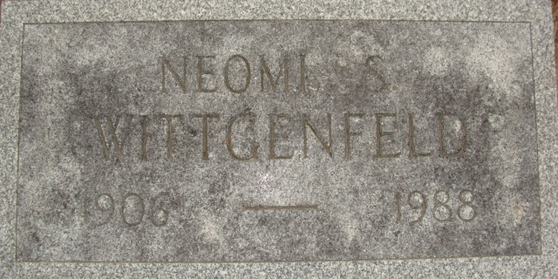
Photo by Alicia Kneuss

Naomi Wittgenfeld
in the Indiana, U.S., Death Certificates, 1899-2017
Name Naomi Wittgenfeld
[Naomi Stults]
Gender Female
Race White
Marital Status Divorced
Age 82
Birth Date 25 Apr 1906
Birth Place Decatur, Indiana
Death Date 23 Dec 1988
Death Place Fort Wayne, Allen, Indiana, USA
Death Registration Date 1988
Father James D Stults
Mother Effie R Kern
Informant Jon D. Wittgenfeld; son; Rochester, New York
Cremation December 28, 1988; Fort Wayne Crematory; Decatur Cemetery

