Jon D. Wittgenfeld
April 13, 1928 – June 27, 2008

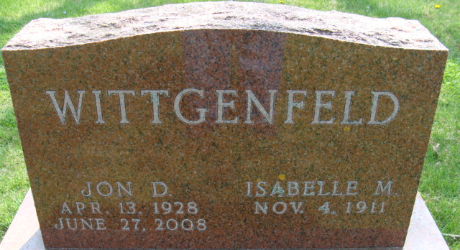
Photo by Alicia Kneuss

Jon D. Wittgenfeld, 80, East Rochester, New York, died June 27. He was a native of Decatur. He married Isabella M. Boling in September of 1951; she died on April 24, 2001. He was a technical writer for Xerox Corp. in Rochester, New York.
Surviving are three daughters, Lucinda C. Bohnas of Chambers, Arizona; Mrs. Ron (Ida) Milligan of Mansfield, Ohio; and Jane Ernsberger of Marion, Ohio; a son, William Huffman of Phoenix, Arizona; a sister, Mrs. Charles (Susan) Clark of Phoenix; two brothers, Dallas Wittgenfeld of Orange City, Florida, and Rick Wittgenfeld of Decatur; 13 grandchildren; and 13 great-grandchildren. A son, a daughter, and a granddaughter are deceased.
A graveside funeral service for him and his wife will be held at 11 a.m. today in Decatur Cemetery.
Decatur Daily Democrat, Adams County, Indiana
Saturday, July 5, 2008

**
U.S., Cemetery and Funeral Home Collection, 1847-Current
Name Jon B. Wittgenfeld
Gender Male; Death Age 80
Birth Date 13 Apr 1928
Birth Place Decatur, Indiana
Residence Place East Rochester, New York
Death Date 27 Jun 2008
Death Place East Rochester
Burial Date 5 Jul 2008
Father George Wittgenfeld
Mother Naomi Wittgenfeld
Spouse Isabelle May Boling
Child Michael Wittgenfeld, William Huffman, Jane Ernsberger, Lucinda Cindy Bohnas, Ruth Ann Gale, Ida Milligan
Siblings Susan Clark, Rick Wittgenfeld, Dallas Wittgenfeld

