Troy Allen Witte
October 25, 1971 – October 25, 1971

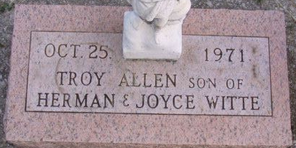
Photo by Alicia Kneuss
Witte Infant Dead at Birth
Troy Allen Witte, infant son of Herman and Joyce Tope-Witte, of 824 North Second Street, was dead at birth at 2:34 a.m. today at the Adams County Memorial Hospital.
Surviving in addition to the parents are two sisters, Janalee and Shelly, and a brother, Robert, all at home; the grandparents, Mr. and Mrs. August Witte of Decatur Route 3, and Mr. and Mrs. Paul Replogle of Van Wert, O., and a great-grandmother, Mrs. Mae Tope of Decatur.
The parents are members of Zion Lutheran Church.
Graveside services will be held at 10 a.m. Tuesday at the Decatur Cemetery, with Rev. Richard C. Ludwig officiating. Arrangements are being handled by the Zwick Funeral Home.
Decatur Daily Democrat; Adams County, Indiana
Monday, October 25, 1971

