Roberta Jean (Eckhart) Witte
September 24, 1959 – April 29, 2014

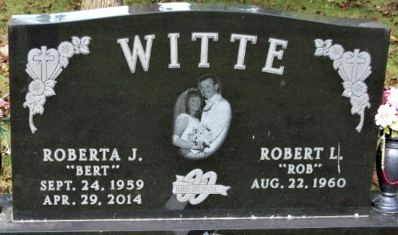
Photo by PLS
Roberta Jean "Berta" Witte, 54 years old of Ohio City, Ohio, passed away at 4:08 a.m. on Tuesday, April 29, 2014, in the Visiting Nurse & Hospice Home located in Fort Wayne, Indiana.
Berta was born on Thursday, September 24, 1959 in Toledo, Ohio the daughter of the late Ivan Charles Eckhart and the late Jessie Marie (Cousino) Eckhart. She married Robert "Rob" Witte on May 18, 1991.
Berta attended Zion Lutheran Church in Decatur, Indiana. She enjoyed spending time with her grandchildren, family, and friends. She loved the outdoors and gardening and spending time at NASCAR races with her husband. She loved driving her 1967 Camaro Convertible and motorcycle riding.
Berta was a self-employed housekeeper; and had formerly been employed by Golden Meadows Home in Decatur, Indiana.
Surviving are her husband, Rob Witte of Ohio City, OH; son, Jim (Stephanie) Eckhart of Beebe, AR; daughter, Doneyelle (Justin) Taylor of Ft. Wayne, IN; daughter, Starr (Adam) Bell of Decatur, IN; son, Robert (Tesh) Thompson-Witte of Monroe, IN; sister, Margaret Lockwood of LaSalle, MI; sister, Darlene (Jay) Bowman of LaSalle, MI; sister, Karen (Al) Lawson of Payne, OH; sister, Jackie (Bill) Alberding of Decatur, IN; brother, Chuck (Sue) Eckhart of Decatur, IN; sister, Elaine (Tom) Hall of Decatur, IN; brother, Tim (Donna) Eckhart of Vera Cruz, IN; brother, Joe (Deb) Eckhart of Convoy, OH; sister, Patti Smeal of Decatur, IN; father & mother-in-law, Herman & Joyce Witte of Decatur, IN; 11 grandchildren: Eric Eckhart, Jessie Eckhart, Jaycee Taylor, Jax Taylor, MaCenzie Thompson-Witte, Seth Thompson-Witte, Chase Thompson-Witte, Aeriana Bell, Brad Bell, Braiden Bell, and Allie Bell.
Preceding Roberta in death was one brother, Terry Eckhart.
Funeral services will be held at 12:00 NOON Saturday, May 3, 2014, in the Zion Lutheran Church with Rev. Phil Phifer officiating. Interment will follow in the Decatur Cemetery, Decatur, Indiana. Friends will be received from 1-4 and 5-8 p.m. Friday, May 2, 2014, in the Zwick & Jahn Funeral Home, Decatur, IN and one hour prior to the service at the church on Saturday.
Preferred memorials are to Zion Lutheran Church or donor's choice.

Zwick & Jahn Funeral Home, Adams County, Indiana
April 29, 2014

