Robert L. Witte
August 22, 1960 -

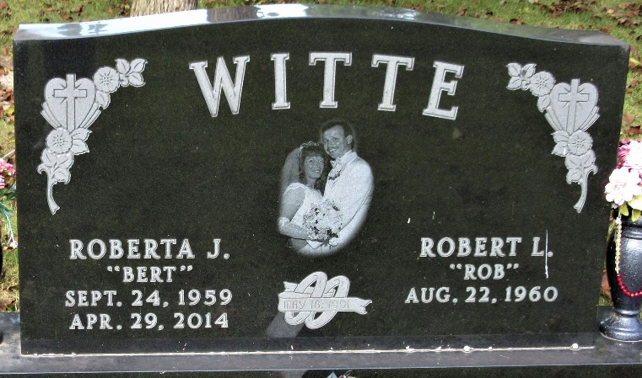
Photo by PLS

