Herman P. Witte
August 7, 1940 – February 14, 2016

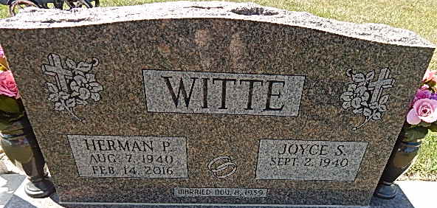
Photo by Alicia Kneuss
Herman P. Witte, 75 years old of Decatur, Indiana, passed away on Sunday, February 14, 2016 at his residence following an illness diagnosed in July. Herm was born on August 7, 1940 in Decatur, Indiana the son of the late August H. Witte and the late Esther (Luttmann) Witte. He married Joyce S. Tope on November 8, 1959 in St. Peter Lutheran Church - Fuelling and she survives.
Herm served his country in the United States Army Reserves.
Herm was a member of the Zion Lutheran Church - Decatur; a former member of the School Board and also a longtime trustee. He was also a member of the American Legion Post #43 in Decatur. Herm loved to restore antique cars and drive them.
He was a graduate of Monmouth High School Class of 1958. Herm loved spending time with his family and teaching them lessons through stories of his life. Attending sports events for his grandchildren brought him great pride and joy. He also loved to tinker and fix anything. IU Basketball was a favorite pastime and it was something to see, Herm watching the game!
Herm retired in 1991 from Navistar after 32 years of service. He had also been employed at the Adams County Highway Dept.; Indiana State Department of Transportation; and North Adams Community Schools.
Surviving are his wife of 56 years, Joyce S. Witte of Decatur, IN; son, Robert "Rob" Witte of Ohio City, OH; daughter, Janalee (John) Cowans of Decatur, IN; daughter, Shelly (Brian) Byerly of Decatur, IN; brother, Vern (Judy) Witte of Decatur, IN; sister, Sharon (Chon) Michael of Ft. Wayne, IN; sister-in-law, Scarlett Witte of Ft. Wayne, IN; 10 grandchildren: Jim (Stephanie) Eckhart; Robert (Nateshia) Witte; Starr (Adam) Bell; Doni (Justin) Taylor; Lucas Cowans; Aaron Cowans; Macy Byerly; Ryan Byerly; Megan Byerly; & Max Byerly; and 14 great-grandchildren: MaCenzie Witte; Seth Witte; Chase Witte; Jaycee Taylor; Jax Taylor; Jessie Eckhart; Eric Eckhart; Brad Bell; Allie Bel l; Braiden Bell; Braycen Bell; Aeriana Bell; Elijah Cruz; Braylen Cowans.
Preceding Herm in death were 1 son, Troy Allen Witte; 1 daughter-in-law, Roberta Witte; 2 brothers: Delbert & Norbert Witte.
Funeral services will be held at 10:30 a.m. Friday, February 19, 2016 in the Zion Lutheran Church with Rev. James Voorman officiating. Interment will follow in the Decatur Cemetery. Military Graveside Services will be conducted by the American Legion Post #43 Color Guard. Friends will be received from 2-5 and 6-8 p.m. Thursday, February 18, 2016 in the Zwick & Jahn Funeral Home, Decatur, IN and one hour prior to the service at the church on Friday.
Preferred memorials are to Zion Lutheran Church - Decatur; American Legion Post #43; or Donor's Choice.

Zwick & Jahn Funeral Home, Adams County, Indiana
February 15, 2016

