Elise S. (Koeneman) Scheimann-Witte
September 28, 1878 – July 7, 1969

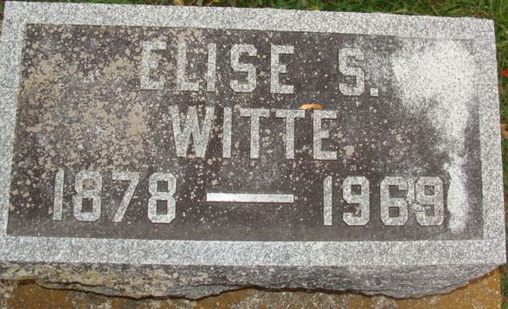
Photo by Alicia Kneuss
Mrs. Elise Witte Dies This Morning
Mrs. Elise Witte, 90, of Ossian, a native of Adams County, died at 8:40 a.m. today at the Lutheran Hospital in Fort Wayne, where she had been a patient two weeks. Born in Adams County on Sept. 28, 1878, she was a daughter of Mr. and Mrs. Karl Koenemann.
Survivors include two stepdaughters; one stepson; two brothers, Fred Koenemann of Tipp City, O., and Thoedore Koenemann of Fort Wayne; and a sister, Mrs. Rose Bloomberg.
Funeral rites will be held at 1:30 p.m. Wednesday at the Elzey Funeral Home at Ossian, with Rev. O. A. Brillinger officiating. Burial will be in the Decatur Cemetery. Friends may call at the funeral home after 12 noon Tuesday.
Decatur Daily Democrat, Adams County, Indiana
Monday, July 7, 1969
**
Indiana, U.S., Death Certificates, 1899-2017
Name Elise Witte
[Elise Koeneman]
Gender Female
Race White
Marital Status Widowed
Age 90
Birth Date 28 Sep 1878
Birth Place Indiana
Death Date 7 Jul 1969
Death Place Fort Wayne, Allen, Indiana, USA
Death Registration Date 1969
Father Karl Koeneman
Mother Eickof
Informant Mrs. Milda Ratcliff; step-daughter; Ossian, Indiana
Burial July 9, 1969; Decatur Cemetery; Decatur, Indiana

