Marjorie Lois (Coates) Withrow-Weidler
May 15, 1921 – July 21, 2016

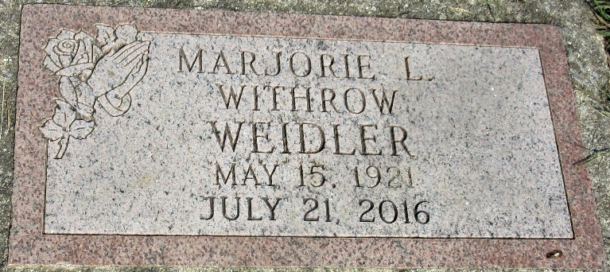
Photo by fPLS
Marjorie Lois (Coates) Withrow Weidler, 95, of Decatur passed away Thursday evening at Adams Woodcrest. She was born May 15, 1921 in Ashland, Wisconsin to Raymond and Maybelle (Harris) Coates. She married Albert W. Withrow on May 27, 1939 in San Jose, California and he preceded her in death on November 24, 1983. On November 19, 1988, she married Arnold N. Weidler in Vera Cruz, Indiana and he preceded her in death on January 23, 2006.
Margie’s father died when she was 5 years old and her mother was forced to place Margie in an orphanage in Wisconsin. At the orphanage Margie learned to knit which became a lifelong hobby. At age 9 Margie went to live with her sister at a logging camp and helped out in the kitchen. A fire destroyed the camp and killed her sister so Margie was returned to the orphanage. At age 14 her mother came and got her and they traveled to Riverside California in the rumple seat of a car. They settled in Riverside and there Margie was able to finish high school and take bookkeeping classes. She had worked as a bookkeeper at the Seventh Day Adventist Southern California Conference in Riverside, California, retiring in 1985. After her retirement, Margie did extensive traveling to the Holy Land, Europe, and Australia. On a flight home to Riverside, she met Arnold Weidler. A year later they married and enjoyed 18 years together traveling to Germany twice and extensively around the U.S.
Margie is survived by her daughter Nancy Withrow Smith of Pleasant View, UT; a son, Albert William Withrow, Jr of Bering Springs, MI; two step-daughters, Arlene J. (Wes) Kuntzman of Monroe, IN and Tami L. (David) DeWille of Wapakoneta, OH; two step-sons, Dan E. (Debbie) Weidler of Ventura, CA and James A. (Catherine) Weidler of Kokomo, IN; five grandchildren, Cynthia and Ronald Smith and Debra, Timothy, & Wendy Withrow; 11 step-grandchildren, Bethany (Kevin) Kuntzman Sinclair; Michael & Jonathan Kuntzman; Crystal & Amanda Seem; Jeni (Michael) Irish; Heather (Jeremy) Hamilton; and Steve, Douglas, Dean, & Brian Barger; ten great-grandchildren; and 13 step-great-grandchildren. She is also survived by four nephews, Tim Coates and Robert Coates of California and Raymond (Lynn) Coates and David (Sandra) Coates of Iron River, Michigan. She was preceded in death by a step-daughter, Nancy C. Brown; two brothers, Robert & Raymond Coates; and two sisters, Crystal & Florence Coates.
A memorial service will be held at 2:00 p.m. Saturday, July 30, 2016 in the Zwick & Jahn Funeral Home in Decatur with Pastor Wes Kuntzman & Pastor Ernie Suman officiating. Interment will follow at the Decatur Cemetery.
Preferred memorials are to Mt. Zion United Brethren Church in Bobo.
Zwick & Jahn Funeral Home, Adams County, Indiana
July 22, 2016

