Robert V. Witham
February 13, 1908 – April 29, 1985

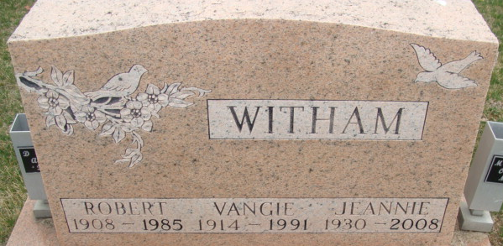
Photo by Alicia Kneuss
Robert V. Witham, 77, 429 Line St., died at 4:15 p.m. Monday at Adams County Memorial Hospital after a lengthy illness. He was born in Decatur on February 13, 1908 to W. H. and Martha Ball Frost Witham and married the former Evangelean "Vangie" Evans in 1930. She survives.
He was a truck driver for 36 years before retirement, working for Belmont Trucking Co. until 1972.
He was also a member of the Baptist church in Saginaw, Michigan and a graduate of the University of Saginaw.
Other survivors include a daughter, Charlotte Jeannie Jacovi, at home; a granddaughter, Cheri, in Indianapolis; and four great-grandchildren.
His funeral will be at 11 a.m. Wednesday in Winteregg-Linn and Haggard Funeral Home, with Rev. Sylvester Martin officiating. Burial will be in Decatur Cemetery. There will be no calling at the funeral home.
Preferred memorials are gifts to the cancer society.
Decatur Daily Democrat, Adams County, Indiana
Tuesday, April 30, 1985

