Charlotte Jean “Jeannie” Witham-Jacobi
July 5, 1930 – June 13, 2008

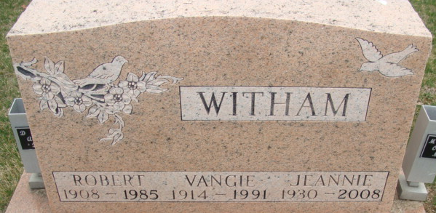
Photo by Alicia Kneuss
Charlotte Jean Jacobi
in the Indiana, U.S., Death Certificates, 1899-2017
Name Charlotte Jean Jacobi
[Charlotte Jean Witham]
Maiden Name Witham
Gender Female
Race White
Marital Status Widowed
Age 77
Birth Date 5 Jul 1930
Birth Place Decatur, Indiana
Death Date 13 Jun 2008
Death Place Indianapolis, Marion, Indiana, USA
Death Registration Date 2008
Father Robert Witham
Mother Evangeline Evans
Informant Cheri D. Davis; daughter; Beech Grove, Indiana
Cremation Columbus Crematory; Columbus, Indiana

