Evangelean “Vangie” M. (Evans) Witham
February 10, 1914 – November 10, 1991

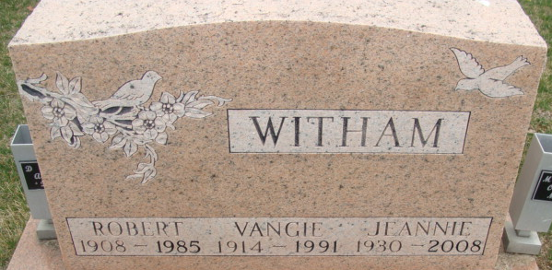
Photo by Alicia Kneuss
Evangelean “Vangie” M. Witham, 77, of Indianapolis died yesterday in Cedar Crest Nursing Home, Indianapolis.
The former Decatur resident was the widow of Robert, who died in 1985.
Surviving are a daughter, Jeannie Jacobi of Indianapolis; brothers, Edward Evans of Decatur and Carl Evans of Waverly, Ohio; a grandchild; and four great-grandchildren.
Private services are tomorrow in Haggard & Armes Funeral Home, Decatur, where calling is 1 to 2 p.m. tomorrow. Burial will be in Decatur Cemetery.
News-Sentinel, Allen County, Indiana
Monday, November 11, 1991
**
Indiana, U.S., Death Certificates, 1899-2017
Name Evangelean M Witham
[Evangelean M Evans]
Gender Female
Race White
Marital Status Widowed
Age 77
Birth Date 10 Feb 1914
Birth Place Adams County, Indiana
Death Date 10 Nov 1991
Death Place Indianapolis, Marion, Indiana, USA
Death Registration Date 1991
Father Ezekiel Evans
Mother Ethel Stettle
Informant Mrs. Jeannie Jacobi; daughter; Indianapolis, Indiana
Burial November 12, 1991; Decatur Cemetery; Decatur, Indiana

