William A. Wisner
September 4, 1841 – September 23, 1904

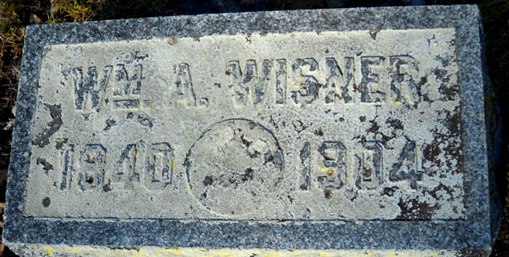
Photo by drbuck

William A Wisner
in the Indiana, U.S., Death Certificates, 1899-2017
Name William A Wisner
Gender Male; Race White
Age 63
Birth Date 4 Sep 1841
Birth Place Washington Tp Adams County
Death Date 23 Sep 1904
Death Place Decatur, Adams, Indiana, USA
Father David Wisner
Mother Lidde Allen
Spouse Adaline
Informant W. T. Wisner; Decatur, Indiana
Burial September 25, 1904; Maplewood Cemetery

**
WILLIAM A. WISNER, a farmer of Washington Township, was born in Adams County September 4, 1840, son of David and Lydia Wisner, the former a native of Pennsylvania and the latter of Ohio. His parents immigrated to Adams County about the year 1836, settling in Washington Township, upon the farm known as the Coffee farm, on section 14. The father bought eighty acres of land, all timber. Previous to moving into his own log cabin, he lived for a short time in a log house situated where Decatur now stands. His first crop was five acres of corn, which he cultivated with a grubbing hoe, he having sold the oxen he brought with him to the county, to secure the necessaries of life. He endured the usual privations and trials of the pioneer, being obliged to go to Fort Wayne with a yoke of cattle over trails in order to get his milling done. The meat consumed in the family was principally wild game which was abundant. He died September 29, 1868, respected by all who knew him. His wife, who still survives, resides in Wells County, and is in her seventy-second year. Of their ten children, seven are living - Thomas, William A., Margaret J., Priscilla, David F., Aaron W. and James A. Previous to the war the father was a Whig, and since that time he has been a Republican. He was a worthy and consistent member of the Presbyterian church.
William A. Wisner has nearly always lived in his native county, and his time has been occupied in working at the carpenter's and cabinet-maker's trades, and in farming. In April, 1861, he enlisted in Company F, Twelfth Indiana Infantry, and was assigned to the army of West Virginia, under General McClellan. He participated in the first battle of Bull Run, Winchester, Antietam, and several others of less importance. In July, 1862, he was discharged and almost immediately re-enlisted in Company H, Eighty-ninth Indiana Infantry, and was assigned to the Army of the Tennessee, Sixteenth Army Corps. He participated in the Red River expedition, being thirty-three days under fire, Fort Dalhousie, Tupelo, Fort Spanish, Fort Blakely and several others. During the second enlistment he was commissioned Second Lieutenant, May 1, 1864, and served in that capacity until February 15, 1865 then being commissioned First Lieutenant served in that capacity until July 19, 1865 being then honorably discharged from the service of the United States Army.
He was married February 4, 1864, to Mrs. Adaline Boothe, born June 28, 1843, in this county, and daughter of Greenberry and Lucinda Le Masters, who settled in Root Township, this county, about the year 1834, and were among the first settlers of the township. Mr. and Mrs. Wisner have had three children - Maggie, Lydia E. and William T. By her first marriage with John Boothe Mrs. Wisner had one child - Edward B. For about six years after his marriage Mr. Wisner resided in Indianapolis and vicinity, after which he returned to Adams County, making this his home ever since. He owns forty acres of land and has been fairly successful as a farmer. They are members of the Methodist Episcopal church, and in politics he is a Democrat.

Biographical and Historical Record - Adams and Wells Co. Indiana Lewis Publishing Co. Chicago, IL 1887

