Barbara Adeline (LeMasters) Wisner
June 28, 1843 – December 26, 1918

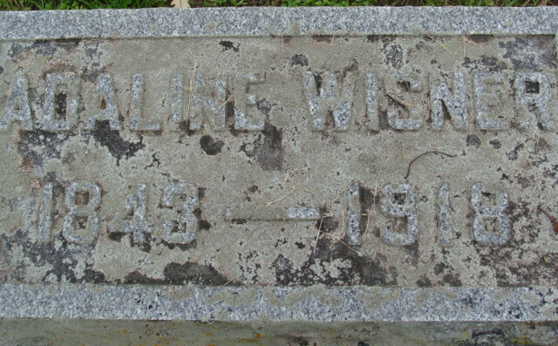
Photo by Alicia Kneuss

Barbary Adeline Wisner
in the Indiana, U.S., Death Certificates, 1899-2017
Name Barbary Adeline Wisner
[Barbary Adeline Lemasters]
Gender Female
Race White
Marital Status Widowed
Age 75
Birth Date 28 Jun 1843
Birth Place Adams County, Indiana
Death Date 26 Dec 1918
Death Place Fort Wayne, Allen, Indiana, USA
Death Registration Date 1918
Father ??rey Lemasters
Mother Lucinda Foster
Spouse William A Wisner
Informant William Wisner; Fort Wayne, Indiana
Burial December 28, 1918; Decatur Cemetery

**
Barbara Adeline / Adaline Lemasters ( Booth ( Wisner from tree Gerald Eugene Family Tree
Record information.
Birth 28 Jun 1843 Adams, Indiana, USA
Marriage 4 Feb 1864 Adams, Indiana, USA
Residence 1900 Adams, Indiana, USA
Death 26 Dec 1918 Fort Wayne, Allen, Indiana, USA
Record information.
Father Greenberry Lemasters (Born 1813)
Mother Lucinda Foster ( Lemasters (Born 1813)
Spouse John Booth
Spouse William A Wisner (1841-1904)

