Thankful A. (Devore) Wisler
October 18, 1851 – August 8, 1914

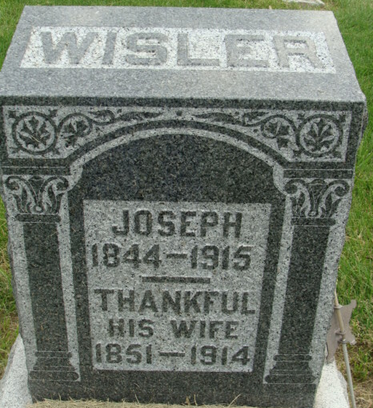
Photo by Alicia Kneuss

A LONG ILLNESS
Culminates in Death of Mrs. Joe Wisler, Well Known Monroe Lady
THIS AFTERNOON AT 2:35
Had Been Ill Seven Weeks of Bronchial Trouble and Complications
An illness of seven weeks of bronchial trouble, fever and complications culminated in the death this afternoon at 2:35 o'clock of Mrs. Joseph Wisler, aged sixty-three, of Monroe.
Mrs. Wisler was a native of Ohio but has lived in Monroe for the past thirty years, being a prominent lady of that town.
Her husband, seventy years of age, survives; also a daughter, Mrs. D. C. Brandyberry who lives at home. One daughter is deceased. Two brothers, George and John Devor, residents of Ohio, and a sister, Mrs. Lucinda Straum, of Benton Harbor, Michigan, are living.
Funeral arrangements had not been made at time of going to press.
Decatur Daily Democrat; Adams County, Indiana
August 8, 1914
**
Thankful A Devore from tree Warner/Devore/Hilligas/McCue Family Tree
Birth 18 Oct 1851 Tuscarawas, Ohio, USA
Marriage 11 Sep 1870 Ohio, Clermont, Ohio, USA
Death 1914 Adams, Indiana, USA
Father Samuel Devore (1822-1906)
Mother Sarah Rhodes (Born 1825)
Spouse Joseph Wisler / Wissler/ Nissler (1847-1895)

