Waldo J. Wiseman
May 12, 1916 – October 12, 1994

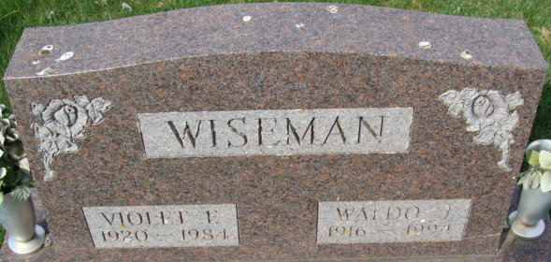
Photo by Alicia Kneuss
Waldo J. Wiseman, 78, of Decatur died yesterday in Woodcrest Nursing Home.
The Ohio City, Ohio, native retired in 1978 as custodian of Monmouth School after 25 years and also worked at Central Soya for 12 years. His wife, Violet F., died in 1984.
Surviving are a son, Richard L. of Urbana, Ohio; sisters, Marcille McDougal and Thelma "Tootie" Allen, both of Ohio City, Helen Shinabery of Rockford, Ohio, and Emma L. Myers of Van Wert, Ohio; brothers, Robert of Delphos, Ohio, and Lloyd "Bud" of Ohio City; three grandchildren; and six great-grandchildren.
Services are 1 p.m. (Indiana time) Saturday in Zwick-Sefton & Jahn Funeral Home, Decatur, where calling is 1 to 4 and 6 to 8 p.m. tomorrow. Burial will be in Decatur Cemetery.
Preferred memorials are gifts to Shriners Hospital for Crippled Children in Chicago or St. Jude Children's Research Hospital in Memphis, Tenn.
News-Sentinel, Allen County, Indiana
Thursday, October 13, 1994
**
Indiana, U.S., Death Certificates, 1899-2017
Name Waldo J Wiseman
Gender Male
Race White
Marital Status Widowed
Age 78
Birth Date 12 May 1916
Birth Place Ohioio City, Ohio
Death Date 12 Oct 1994
Death Place Decatur, Adams, Indiana, USA
Father Pete Wiseman
Mother Lizetta Rayer
Informant Richard Wiseman; son; Urbana, Ohio
Burial October 15, 1994; Decatur Cemetery; Decatur, Indiana

