Violet Fern (Girod) Wiseman
October 22, 1920 – January 28, 1984

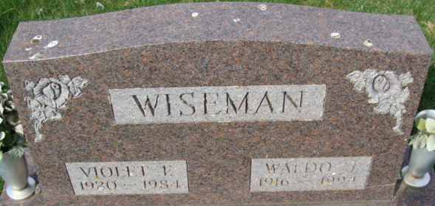
Photo by Alicia Kneuss
Violet Fern Wiseman
in the Indiana, U.S., Death Certificates, 1899-2017
Name Violet Fern Wiseman
[Violet Fern Girod]
Gender Female
Race White
Marital Status Married
Age 63
Birth Date 22 Oct 1920
Birth Place Indiana
Death Date 28 Jan 1984
Death Place Fort Wayne, Allen, Indiana, USA
Death Registration Date 1984
Father Eli Girod
Mother Bessie May
Spouse Waldo J. Wiseman
Informant Waldo J. Wiseman; husband; Decatur, Indiana
Burial February 1, 1984; Decatur Cemetery; Decatur, Indiana

