Jeanette E. (Roth) Wiseman
November 18, 1946 – June 30, 2024

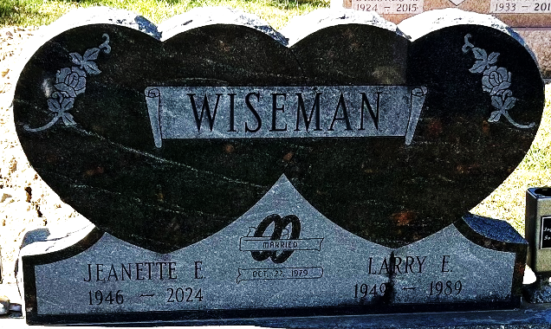
Photo by Deb Curry
Jeanette Wiseman, 77, of Decatur, Indiana passed away Sunday, June 30, 2024, at Adams Woodcrest. She was born November 18, 1946, in Van Wert, Ohio to the late Richard Leroy Roth and Gladys Bernice (Shock) Roth. On October 27, 1979, she married Larry Eugene Wiseman and he preceded her in death on April 8, 1989.
Jeanette was a 1964 graduate of Adams Central High School. She was employed at Adams Memorial Hospital in the payroll department for 26 years. Jeanette enjoyed crocheting and was an avid bird watcher.
She is survived by her sister, Judy (Ned) Lautzenheiser of Decatur, Indiana; half-sister, Shirley (Doug) Whitaker of Bluffton, Indiana; half-brother, Neal (Ann) Roth of Portland, Indiana; six nieces and nephews, David (Julie) Roth, Leah Roth, Greg Lautzenheiser, Lynne (Phil) Yaryan, Elizabeth King, and Jamie Roth. In addition to her parents and husband, she was preceded in death by two brothers, David A. and Michael R. Roth.
A funeral service will be held at 10:00 a.m. Wednesday, July 3, 2024, at Decatur Baptist Church in Decatur with Pastor Andrew Lyons officiating. Burial will follow at the Decatur Cemetery. Friends and family will be received from 5 to 7 p.m. Tuesday, July 2, 2024 at Zwick & Jahn Funeral Home in Decatur and one hour prior to the service on Wednesday at the church.
Preferred memorials are to the family.
Zwick & Jahn Funeral Home, Adams County, Indiana
July 4, 2024

