Lucy Jane (Hunter) Wisehaupt
May 13, 1857 – May 11, 1927

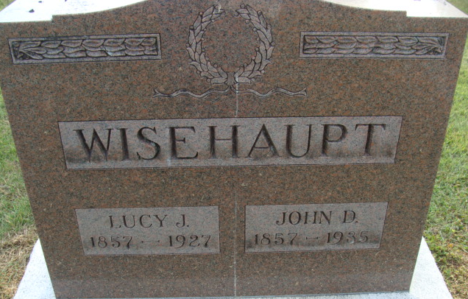
Photo by Alicia Kneuss

Lucy Jane Wisehaupt
in the Indiana, U.S., Death Certificates, 1899-2017
Name Lucy Jane Wisehaupt
[Lucy Jane Hunter]
Gender Female
Race White
Marital Status Married
Age 69
Birth Date 13 May 1857
Birth Place Ohio
Death Date 11 May 1927
Death Place Decatur, Adams, Indiana, USA
Death Registration Date 1926-1927
Father Daniel Hunter
Mother Elizabeth Reed
Spouse John Wisehaupt
Informant Howard Wisehaupt; Decatur, Indiana
Burial May 14, 1927; Decatur Cemetery

