William Leroy Wise
October 31, 1908 – October 13, 1910

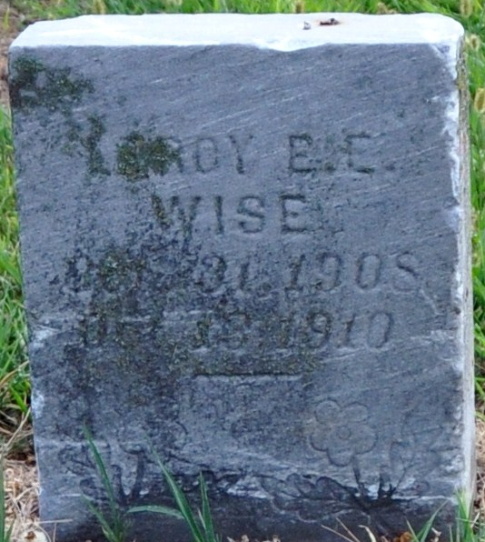
Photo by Deb Curry

Wm Leroy Wise
in the Indiana, U.S., Death Certificates, 1899-2017
Name Wm Leroy Wise
Gender Male
Race White
Marital Status Single
Age 1
Birth Date 31 Oct 1908
Birth Place Adams, Indiana
Death Date 13 Oct 1910
Death Place Washington, Adams, Indiana, USA
Death Registration Date 1910
Father Willis Wise
Mother Mertle Elzey
Informant Mrs. Myrtle Wise; Decatur, Indiana
Burial Oct. ?, 1910; Maplewood Cemetery

