Mary E. (Butler) Wise-Reynolds
July 27, 1919 – March 31, 2002

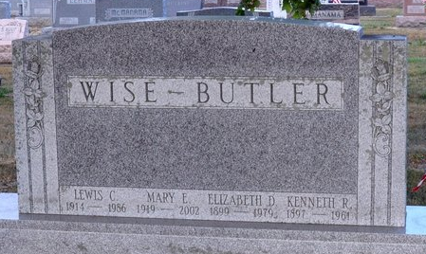
Photo by Deb Curry

Mary E. Wise Reynolds, 82, died Sunday at Lutheran Hospital. Born in Adams County, she was a homemaker and ran the family farm. Her first husband, Lewis C. Wise, died in 1986.
Surviving are her husband, John D. Reynolds Sr.; a stepdaughter, Elizabeth Johnson of Indianapolis; two step sons, Richard N. Reynolds of Fort Wayne and John D. Reynolds Jr. of Atlanta; six cousins, Judy Butler Murray, Tom Butler, Joe Butler, Paul Butler, Jack Butler and Jim Butler, all of Decatur; three step-grandchildren; and five step-great-grandchildren.
Services at 2 p.m. Wednesday at Zwick & Jahn Funeral Home, Decatur. Calling from 2 to 4 and 6 to 8 p.m. Tuesday at the funeral home and an hour before Wednesday services. Burial in Decatur Cemetery.
Memorials to the American Lung Association or Adams County Heart Club.

Journal Gazette, Allen County, Indiana
Monday, April 1, 2002
**
Indiana, U.S., Death Certificates, 1899-2017
Name Mary E Wise-Reynolds
[Mary E Butler]
Gender Female
Race White
Marital Status Married
Age 82
Birth Date 27 Jul 1919
Birth Place Adams County, Indiana
Death Date 31 Mar 2002
Death Place Fort Wayne, Allen, Indiana, USA
Death Registration Date 2002
Father Kenneth Butler
Mother Elizabeth Dailey
Spouse John D Reynolds
Informant John D. Reynolds; husband; Decatur, Indiana
Burial April 3, 2002; Decatur Cemetery; Decatur, Indiana

