Louis Wise
July 9, 1848 – September 25, 1930

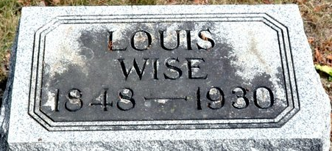
Photo by Deb Curry

Indiana, U.S., Death Certificates, 1899-2017
Name Louis Weis (sic)
Gender Male
Race White
Marital Status Widowed
Age 82y 2m 16d
Birth Date 9 Jul 1848
Birth Place Germany
Death Date 25 Sep 1930
Death Place Fort Wayne, Allen, Indiana, USA
Death Registration Date 1930
Spouse Lusame Weis (deceased)
Parents unknown
Informant Mrs. Rosa Spade
Burial Decatur, IN 9/29/1930

