Lewis C. Wise
November 8, 1914 – October 13, 1986

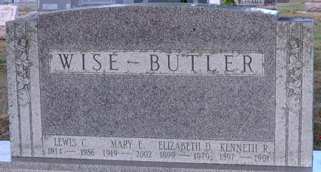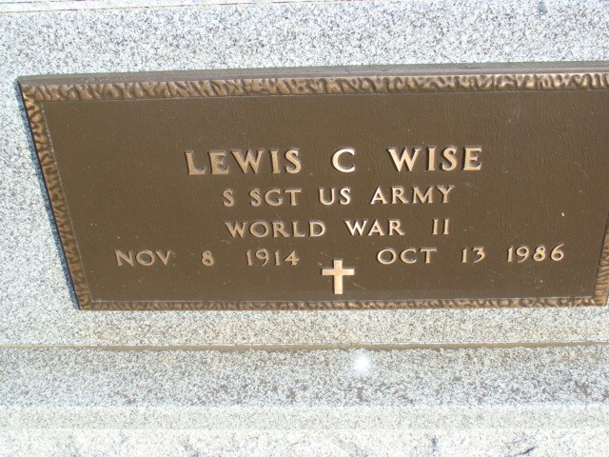
Photo by Deb Curry

Lewis C Wise
in the Indiana, U.S., Death Certificates, 1899-2017
Name Lewis C Wise
Gender Male
Race White
Marital Status Married
Age 71
Birth Date 8 Nov 1914
Birth Place Ohio
Death Date 13 Oct 1986
Death Place Fort Wayne, Allen, Indiana, USA
Death Registration Date 1986
Father Walter Wise
Mother Susie Sheets
Spouse Mary Butler
Informant Mary Wise; wife; Decatur, Indiana
Burial October 16, 1986; Decatur Cemetery; Decatur, Indiana

