Jacob Wise
August 28, 1885 – January 11, 1969

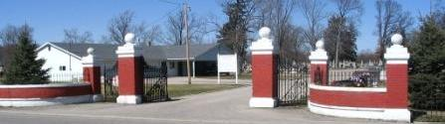
Photo by Barbara Baker Anderson

Jacob Wise Dies at Home

Jacob Wise, 83, a resident for many years of the Adams County Home, died at 3 p.m. Friday at the South View Nursing Home at Bluffton, where he had been a patient two years. He was born in Decatur Aug. 28, 1885, a son of Mr. and Mrs. Lewis Wise.
There are no known survivors.
Funeral rites will be held at 1:30 p.m. Monday at the Adams County Home Chapel from 12 noon Monday until time of the services. The Winteregg-Linn Funeral Home is in charge of arrangements.

Decatur Daily Democrat, Adams County, Indiana
Saturday, January 11, 1969
**
Indiana, U.S., Death Certificates, 1899-2017
Name Jacob Wise
Gender Male
Race White
Age 83
Marital Status Never Married (Single)
Birth Date 28 Aug 1885
Birth Place Indiana
Death Date 11 Jan 1969
Death Place Bluffton, Wells, Indiana, USA
Death Registration Date 1969
Father: Lewis Wise
Informant: Charles Morgan; no relation; Decatur, Indiana
Burial: January 13, 1969; Decatur Cemetery; Decatur, Indiana

