Elva Gertrude (Shifferly) Wise
January 25, 1890 – February 25, 1920

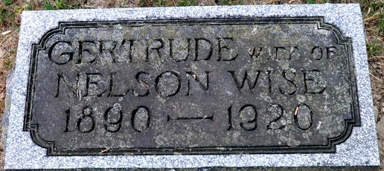
Photo by Deb Curry

DIED NEAR WREN
Mrs.. Elva Daughter of Mr. and Mrs. J. W. Shifferly, Died WEDNESDAY NOON
A Victim of Pneumonia - Funeral will be Held Friday Afternoon at 1:00
Mrs. Elva Gertrude Wise, daughter of Mr. and Mrs. J. W. Shifferly, of east of this city, died yesterday, at 12:30 o'clock at her home. 10 miles east of Wren, Ohio. Death was due to influenza which developed into pneumonia.
She leaves to mourn their loss, the husband, J. N Wise; the father and mother, Mr. and Mrs. J. W. Shifferly; one sister, Mrs. Morris Brown, of Van Wert County, Ohio, and three brothers, Vernon G. Shifferly, of Sturgis, Mich.; Otis E. Shifferly, of St. Mary's Township and Ivan D. Shifferly, at home; besides a number of other relatives and friends who will be grieved to hear of her untimely death.
The funeral services will be held at the Calvary Church, east of this city, Friday afternoon at 1 o'clock, Rev. E. H. Baumgartner, officiating. Interment will be made in the Maplewood Cemetery.
Decatur Daily Democrat; Adams County, Indiana
Thursday, February 26, 1920
**
Gertrude Elva Shifferly from tree CrazyNuts
Birth 25 Jan 1890 Allen, Indiana, USA
Residence 1910 Adams, Indiana, USA
Death 25 Feb 1920 Van Wert, Van Wert, Ohio, USA
Father John William Shifferly (1853-1924)
Mother Lydia Fuhrman (1856-1924)
Spouse Nelson Wise

