Walter Dale Winteregg
March 6, 1921 – June 9, 1962

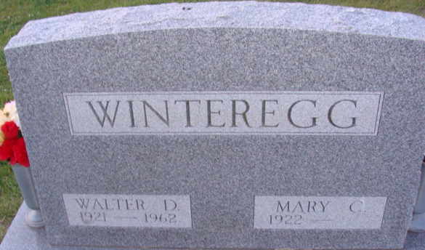
Photo by Alicia Kneuss

Walter Dale Winteregg
in the Indiana, U.S., Death Certificates, 1899-2017
Name Walter Dale Winteregg
Gender Male
Race White
Marital Status Married
Age 41
Birth Date 6 Mar 1921
Birth Place Indiana
Death Date 9 Jun 1962
Death Place Fort Wayne, Allen, Indiana, USA
Death Registration Date 1962
Father Elroy Winteregg
Mother Myrtle Moser
Informant Irene Byron Hospital records; Fort Wayne, Indiana
Burial June 12, 1962; Decatur Cemetery; Decatur, Indiana

