Mary M. (Merriman) Winteregg
October 6, 1915 – February 2, 2015

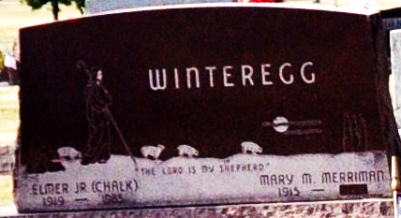
Photo by Deb Curry

Mary M. Winteregg, 99, of Decatur, passed away Monday, Feb. 2, 2015. Born Oct. 6, 1915, in Adams County, she was the daughter of the late Bert G. and Ida A. (Yager) Merriman. On Oct. 5, 1940, she married Elmer "Chalkie" Winteregg Jr., he preceded her in death on Feb.3, 1985.
Mary was a member of St. Mark's United Methodist Church, where she was a member of the former Mary Circle, and served on numerous committees. She was a homemaker and also former partner along with her husband of Winteregg & Linn Funeral Home. She belonged to the "Walkie Talkies" and was an avid bowler. She enjoyed the company of her family and friends. She resided at Woodcrest Campus for 22 years.
Mary is survived by her son, David W. (Cathy) Winteregg of Lebanon, Ind.; her daughter, Janet S. (Lynn) Lipp of Ossian, Ind.; three granddaughters, Randi Foster of Indianapolis, Ind., Tara Tresslar of Andrews Air Force Base, Maryland and Andrea Diewald of Stuttgart, Germany; and three great-grandchildren. She was also preceded in death by two brothers; and three sisters.
Funeral Service is 10 a.m. Friday, Feb. 6, 2015 at Woodcrest Porter Auditorium with calling one hour prior. Chaplain John Follett officiating. Calling also from 4 to 7 p.m. Thursday, Feb. 5, 2015 at Haggard-Sefton & Hirschy Funeral Home. Burial in Decatur Cemetery with Pastor Chris Gadlage conducting the committal.

Haggard & Sefton Funeral Home, Adams County, Indiana
February 3, 2015

