Elmer “Chalk” Winteregg, Jr.
November 27, 1919 – February 3, 1985

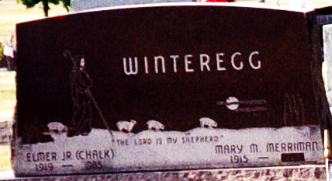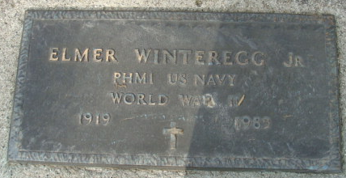
Photo by Deb Curry

Elmer Winteregg, Jr.

Decatur – Elmer “Chalky” Winteregg, Jr., 65, died at 3 am Sunday at Lutheran Hospital in Fort Wayne after a month’s illness. Born November 27 in Berne, he was the son of Elmer and Dora Hirschy Winteregg and was married to Mary Merriman, who survives.
He served 44 years as a funeral director and was a partner in the Winteregg, Linn and Haggard Funeral Home until retirement in January of 1984.
A member of the St. Mark’s United Methodist Church, he was a veteran of World War II, having served as a pharmacist’s mate 1st Class with the United States Navy.
His other memberships included the Decatur Rotary, Moose Lodge, VFW, American Legion and the Indiana Funeral Directors Association.
Survivors, in addition to the wife are a daughter, Janet Lipps of Ossian; a son, David Winteregg of Lebanon and a sister, Christine Moser of Elwood.
Friends may call at the Winteregg, Linn and Haggard Funeral Home in Decatur after 7 pm tonight, all day Tuesday and until noon Wednesday.
Funeral services will be at 2 pm Wednesday at St. Mark’s United Methodist Church with the Revs. James Hook and Jerry Dinsmore officiating. Burial will be in the Decatur Cemetery. Graveside military rites will be administered by the Decatur American Legion post.
The family prefers memorials be directed to the St. Mark’s United Methodist Church.

The Call Leader, Elwood, Indiana
Monday, February 4, 1985

**
Indiana, U.S., Death Certificates, 1899-2017
Name Elmer Winteregg Jr
Gender Male
Race White
Marital Status Married
Age 65
Birth Date 27 Nov 1919
Birth Place Indiana
Death Date 3 Feb 1985
Death Place Fort Wayne, Allen, Indiana, USA
Death Registration Date 1985
Father Emer Winteregg
Mother Dora Hirschy
Spouse Mary Merriman
Informant Mary Winteregg; Decatur, Indiana
Burial February 6, 1985; Decatur Cemetery; Decatur, Indiana

