Will F. Winnes
May 25, 1881 – April 2, 1973

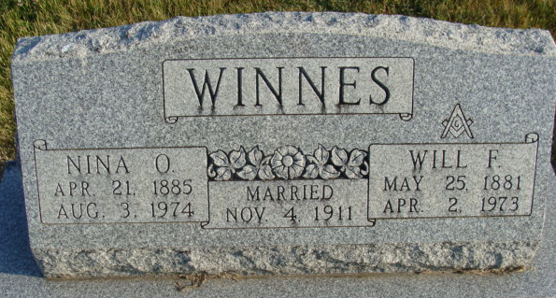
Photo by Alicia Kneuss
Will Winnes, 91, Dies at Hospital
Will F. Winnes, 91, of 604 Short Street, a retired Washington Township Assessor died at 9 p.m. Monday at the Adams County Memorial Hospital. He had been hospitalized four days.
Mr. Winnes served as township assessor for 28 years. He was a member of the First Baptist Church, Decatur Lodge 571 F & AM, the Scottish Rite and the York Rite.
Born on May 25, 1881, he was the son of Henry and Anna B. Forster-Winnes, and was married to Nina O. Reed on November 4, 1911. They were married 61 years.
Surviving are the wife; three daughters, Miss Ruth E. Winnes, Decatur, supervisor of the X-Ray Department at the Adams County Memorial Hospital; Mrs. Willard (Anne) Redmond, Fort Wayne and Mrs. Neil (Jeanette) Highland, Decatur; one sister, Miss Jessie E. Winnes, Decatur; three grandchildren and two great-grandchildren. Five sisters and five brothers preceded him in death.
Funeral services will be held at 10:30 a.m. Wednesday at the Winteregg-Linn Funeral Home, with Rev. Allen B. Roberts officiating. Burial will be in the Decatur Cemetery. Friends may call at the funeral home from 7 to 9 p.m. tonight. Masonic services will be held at 7:30 p.m. tonight.

Decatur Daily Democrat, Adams County, Indiana
Tuesday April 3, 1973

