Ruth E. Winnes
February 4, 1914 – May 3, 2002

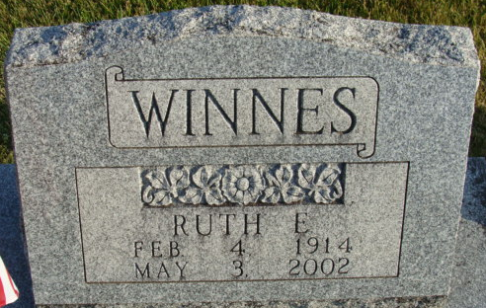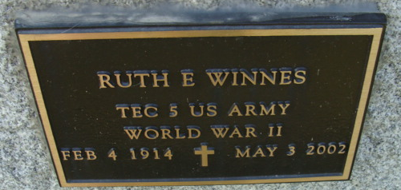
Photo by Alicia Kneuss
Ruth E. Winnes, 88, of Monroeville, a World War II U.S. Army veteran, died Friday, May 3, 2002, at Village of Heritage. The Adams County native had worked for Adams County Memorial Hospital in Decatur in the X-ray department for 25 years and was head X-ray technician for 13 years. She was also a volunteer at the hospital gift shop for 20 years.
Surviving are sisters Anne E. Redmond of Fort Wayne and Jeanette Highland of Decatur; nephews Ron Highland of New Haven, Dave Redmond of Centerville, Ohio, and Bill Redmond of Arlington, Va.; and several great-nieces and great-nephews.
Private family services were held. Burial was at Decatur Cemetery, Decatur.
Memorials are to Adams County Memorial Hospital.
News-Sentinel, Allen County, Indiana
Tuesday, May 7, 2002

**
Indiana, U.S., Death Certificates, 1899-2017
Name Ruth E Winnes
Gender Female
Race White
Marital Status Never Married (Single)
Age 88
Birth Date 4 Feb 1914
Birth Place Indiana
Death Date 3 May 2002
Death Place Monroeville, Allen, Indiana, USA
Death Registration Date 2002
Father Will F Winnes
Mother Nina O Reed
Informant Mr. Ron Highland; nephew; New Haven, Indiana
Cremation Northern Indiana Crematory Corp.; Fort Wayne, Indiana

