Nina O. (Reed) Winnes
April 21, 1885 – August 3, 1974

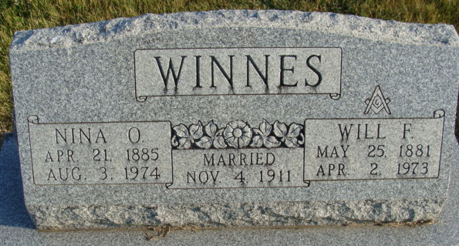
Photo by Alicia Kneuss
Nina O. Winnes Dies at Age 89
Mrs. Nina O. Winnes, 89, of 604 Short St., died at 6:02 p.m. Saturday at the Adams County Memorial Hospital, following an extended illness. She was a member of the First Baptist Church.
Born in Ridgeville on April 21, 1885, she was the daughter of Enos and Margaret Rowland-Reed, and was married on Nov. 4, 1911, to Will F. Winnes, who died April 2, 1973.
Surviving are three children, Miss Ruth Winnes of Decatur, supervisor of the X-Ray Department of the Adams County Memorial Hospital; Mrs. Neil (Jeanette) Highland of Decatur; Mrs. Willard A. (Anne) Redmond of Fort Wayne; three grandchildren and two great-grandchildren. Two sisters and three brothers preceded her in death.
Funeral services will be held at 10 a.m. Tuesday at the Winteregg-Linn and Haggard Funeral Home, with Rev. Sylvester Martin officiating. Burial will be in the Decatur Cemetery. Friends may call at the funeral home from 7 to 9 p.m. tonight.
Preferred memorials are to the Cancer fund.

Decatur Daily Democrat, Adams County, Indiana
Monday, August 5, 1974

