Nelle E. Winnes
November 27, 1876 – December 19, 1972

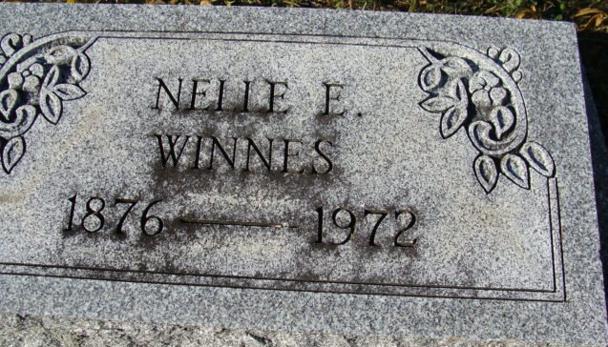
Photo by Alicia Kneuss
Nelle Winnes, 96, Former Teacher, Dies at Hospital
Miss Nelle E. Winnes, aged 96, of 421 West Jefferson Street, a long time Decatur School teacher, died at 3 p.m. Tuesday at the Adams County Memorial Hospital, where she had been a patient for three and one-half weeks.
Miss Winnes taught one year in the Peterson School, and then joined the Decatur Elementary School System, teaching for 46 years in this city, the longest tenure of any teacher here. She retired in 1941.
Member of a pioneer Decatur family, she was born here Nov. 27, 1876, a daughter of Henry and Anna Barbara Winnes, and was never married. Miss Winnes attended the First Baptist church.
Surviving are one sister, Miss Jessie E. Winnes of Decatur; one brother, Will Winnes of Decatur; and several nieces and nephews. Three sisters and six brothers are deceased.
Funeral services will be conducted at 10:30 a.m. Thursday at the Winteregg-Linn Funeral Home, with Rev. Allen B. Roberts officiating. Burial will be in the Decatur Cemetery. Friends may call at the funeral home from 7 to 9 p.m. today.
Preferred memorials are to the building fund of the First Baptist Church.
Decatur Daily Democrat, Adams County, Indiana
Wednesday, December 20, 1972

