Franz Henry Winnes
November 18, 1835 – May 15, 1899

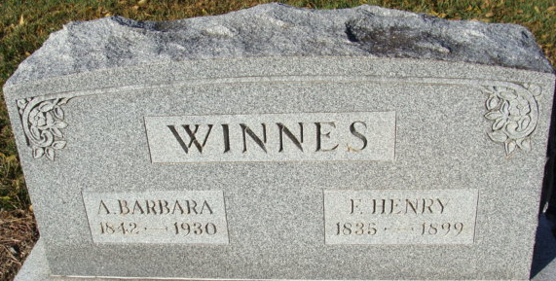
Photo by Alicia Kneuss
HENRY WINNES.
The hearts of our citizens are saddened this week on account of the death of Henry Winnes, one of the city's best known and most conservative businessmen. His death occurred rather suddenly at his home on Jefferson Street Monday afternoon at four o’clock. He had been sick for several days, but not until Monday morning was his condition considered serious and when the news came in the afternoon that he was at the point of death, it came as a terrible shock to his army of friends. It can be truly said that no citizen of Decatur had more warmer and earnest friends than he and the expressions of grief and sympathy for the loved ones who are left to mourn their loss, can be heard on every side. On Wednesday of last week, he was attacked with congestion of the lungs. Every possible care was given to him, and he seemed to improve nicely until Saturday morning when he thought himself well enough to go to his store, which he did. The strain was too much, however, and he broke down completely and had to be taken home. He was cared for by tender and loving hands, but the relapse was too severe for even his strong constitution. He grew steadily worse until about 3:45 Monday afternoon, at which time the brothers who were attending him, were raising him in order to give him some medicine, when he suddenly began sinking and within a few moments fell into that sleep from which there is no awakening save in the land where all is happiness. The family are grief stricken over the terrible sadness brought to their home and the sympathy of the community is with them in their hour of trouble.
Henry Winnes was born in Waldorf Baden, Germany, November 18, 1835, and here he spent his boyhood days and received his schooling. In December 1853, he came with his parents to New York and shortly afterwards to Philadelphia. Here they resided a number of years and during that time Henry learned the shoemaker's trade. He was married July 20,1862, to Miss Barbara Forester, of Philadelphia, and to them have been born twelve children, seven of whom, with the aged helpmate, survive him.
In 1866 Mr. and Mrs. Winnes removed to Decatur and have since been residents. Upon his arrival here the subject engaged in the manufacturing and retailing of boots and shoes until the year 1881, when, on account of failing health, he closed out his stock and engaged in the sawmill and timber business in partnership with Emanuel Woods. They continued in business until January 1883, when they dissolved partnership and the following February Mr. Winnes again engaged in the shoe business, which he continued until the present time, he having been located for several years in the Niblick block, corner of Monroe and Second Streets.
He has always been an earnest patriotic citizen and he was admired by all who knew him for his firmness and strength of character. He has been a member of the Masonic order since 1891 and of the Odd Fellows since 1867 and to both of these fraternities he was strongly attached. He was a true brother in every sense of the word and many members of the lodges are better and truer men today from having associated with him. He was also a member of the Encampment, Chapter and Eastern Star, subordinate orders to the Odd Fellows and Masonic fraternities, and in all of them he was an earnest, industrious, faithful worker and believer. Many years ago he served as town councilman for Decatur and his official duties were transacted in his exact and business like manner. His eldest son, Harry, who has been a resident of Reedley, California, for many years, was the only one of the children not at home, and a telegram received Tuesday gives the information that he will be home to attend the funeral.
The services will be conducted Sunday morning at 10:30 from the Methodist Church, under the auspices of the Masons and Odd Fellows. Rev. H. H. Smith, of Wren, Ohio, will officiate, assisted by Rev. Kruse of the Reformed church of this city. Interment in Maplewood Cemetery.
Decatur Democrat; Adams County, Indiana
Thursday, May 18, 1899

**
Franz Henry Winnes from tree Lewis Family Tree
Birth 1835 Baden-Württemberg, Germany
Residence 5 Jun 1880 Decatur, Adams, Indiana, USA
Death 1899 Adams, Indiana, USA
Father Christopher Winnes (Born 1795)
Mother Barbara Winnes (Born 1794)
Spouse Anna Barbara Foerster (1842-1930)

