Annie E. Winnes
November 17, 1863 – June 6, 1944

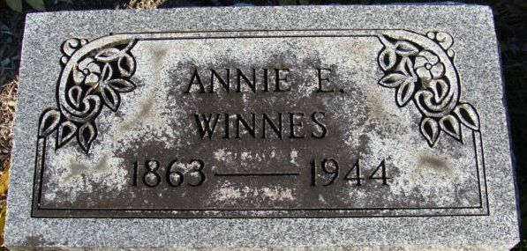
Photo by Alicia Kneuss
Miss Annie E Winnes
in the Indiana, U.S., Death Certificates, 1899-2017
Name Miss Annie E Winnes
Gender Female
Race White
Marital Status Single
Age 80
Birth Date 17 Nov 1863
Birth Place Philadelphia, Pennsylvania
Death Date 6 Jun 1944
Death Place Decatur, Adams, Indiana, USA
Death Registration Date 1944
Father Henry Winnes
Mother Barbara Foester
Informant Miss Jess Winnes; Decatur, Indiana
Burial June 9, 1944; Decatur Cemetery; Decatur, Indiana

