Anna Barbara (Forester) Winnes
March 5, 1842 – April 10, 1930

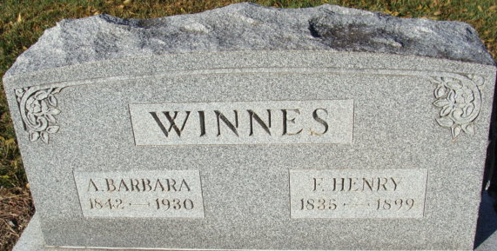
Photo by Alicia Kneuss
AGED DECATUR LADY EXPIRES
Mrs. Henry Winnes Is Victim of Death; Was Pioneer Resident
Mrs. Anna Barbara Winnes, 88, widow of the late Henry Winnes, died at her home at 421 West Jefferson Street, at 9:45 o'clock this morning. Death was caused by the infirmities of old age.
The deceased became bedfast on October 15, 1929 and since that time grew steadily weaker until her death today. Mrs. Winnes had lived in her home on Jefferson Street for over fifty years and during that time was a member of the firm of Winnes Shoe Store. She was a charter member of the Baptist church of this city and was a devoted member until her health prevented her from attending.
She was born in Bavaria, Germany, March 5, 1842, the daughter of Mr. and Mrs. John Forester, both deceased. Surviving are the following children: Annie E. Winnes of this city; Mrs. Nettie Miller of Royal Oak, Michigan: Nellie Winnes, at home; Fred Winnes of Kila, Montana; Will Winnes of this city, and Jessie Winnes at home. Seven grandchildren and two great grandchildren also survive.
One sister, Mrs. Emma Kennel, and a brother, Ernest Forester reside at Baltimore. Md.
The deceased was one of the oldest residents of this city. During her youth she was active in social and business life in Decatur. She was voted to life membership in the Rebekah Lodge and was a charter member of the Eastern Star Lodge, and attended both faithfully until her health failed.
Friends may view the remains at the Winnes residence after Friday evening at 7:30 o’clock. Funeral arrangements have not been completed.
Decatur Daily Democrat; Adams County, Indiana
Thursday, April 10, 1930
**
Winnes Funeral Held
Funeral services were held at 2 o’clock Sunday afternoon for Mrs. Henry Winnes, who died Thursday morning, at the Winnes home, 421 West Jefferson Street. Rev. O. E. Miller officiated and was assisted by Rev. M. W. Sunderman. Burial was made In the Decatur cemetery.
Those from out-of-town who attended the funeral were, Mr. and Mrs. Hugh Miller, Miss Mildred Miller, Mr. and Mrs. H. W. Miller and daughters Susan and Sally of Royal Oak, Michigan; Miss Gretchen Miller of Hillsdale, Michigan; Mr. and Mrs. Edgar Lewis of Denver, Ind.; Mrs. E. A. Rocholl, Mr. and Mrs. Rudolph Humbler, Mrs. Fred Byer, Mrs. Herman Miller, Mrs. Cable, Mr. and Mrs. J. J. Ault and family, Mr. and Mrs. Russel Harruff and family, all of Fort Wayne; Mr. and Mrs. Abner Elzey of Ossian, Mr. and Mrs. T. A. Gottschalk of Berne, Mr. and Mrs. Henry Harrison, J. Frank Mann of Muncie, Duke Stoops of Petersburg, Mr. and Mrs. Harve Smith of Paulding, Ohio; and Don Lammiman of Chicago, IL.
Decatur Daily Democrat; Adams County, Indiana
Monday, April 14, 1930
**
Anna Barbara Foerster from tree Lewis Family Tree
Birth Mar 1842 Germany
Residence 8 Apr 1930 Decatur, Adams, Indiana, USA
Death 1930 Adams, Indiana, USA
Spouse Franz Henry Winnes (1835-1899)

