Caroline (Wiesenauer) Weingarden
July 14, 1892 – November 27, 1950

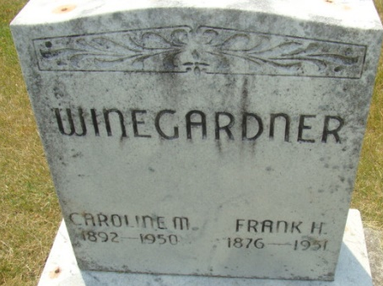
Photo by Alicia Kneuss
Caroline Winegardner
in the Indiana, U.S., Death Certificates, 1899-2017
Name Caroline Winegardner
Gender Female
Race White
Marital Status Married
Age 58
Birth Date 14 Jul 1892
Birth Place Michigan
Death Date 27 Nov 1950
Death Place Decatur, Adams, Indiana, USA
Father Henry Wiesenauer
Mother Unknown
Informant Frank Winegardner; Decatur, Indiana
Burial November 30, 1950; Decatur Cemetery; Decatur, Indiana
**
Michigan, U.S., Marriage Records, 1867-1952
Name Caroline Wiesnaurer
Gender Female
Race White
Age 32
Birth Date abt 1892
Birth Place Huron County, Michigan
Marriage Date 17 Apr 1924 (first marriage)
Marriage Place Bach, Tuscola, Michigan, USA
Residence Place Unionville, Michigan
Father Geo Wiesnaurer
Mother Louise Luckhard
Spouse F H Weingarden
Record Number 30

