Ruby E. (Ford) Windmiller
October 14, 1923 – June 27, 2012

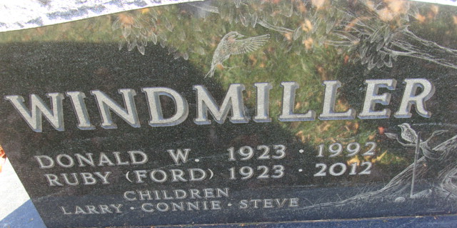
Photo by Alicia Kneuss
Ruby E. Windmiller, 88, of Decatur died at her residence on Thursday, June 27, 2012. Ruby was born in Jay County on October 14, 1923 to the late Virgil V. and Mary Ellen (Orr) Ford. She married Donald W. Windmiller in January of 1945. He preceded her in death May, 1992.
Ruby was a member of the First Presbyterian Church and the Mary-Martha Circle. She was also a member of the Order of the Eastern Star, Adams County Heart Club and the Adams County Extension Homemakers. She retired as a registered nurse, working for Jay County and Adams County Hospitals and Dr. Richard Connelly.
Survivors are two sons Larry (Kathleen Welch) Windmiller of Ft. Wayne and Steve (Jana Shackley) Windmiller of Decatur; a daughter Connie (Jim) McGowin of Ft. Wayne; 5 grandchildren and 7 great grandchildren. She was preceded in death by a brother Arthur Ford.
Visitation will be from 11:00 a.m.-3:00 p.m. on Sunday, July 1, 2012 at Haggard-Sefton & Hirschy Funeral Home. Funeral services will be at 10:00 a.m. Monday, July 2nd also at the funeral home. Pastor Marcia Kline will be officiating and burial is in Decatur Cemetery.
Memorials are to Adams County Heart Club.
Haggard-Sefton & Hirschy Funeral Home, Adams County, Indiana
June 28, 2012

