Lelah Marie Windmiller
May 15, 1974 – March 20, 2022

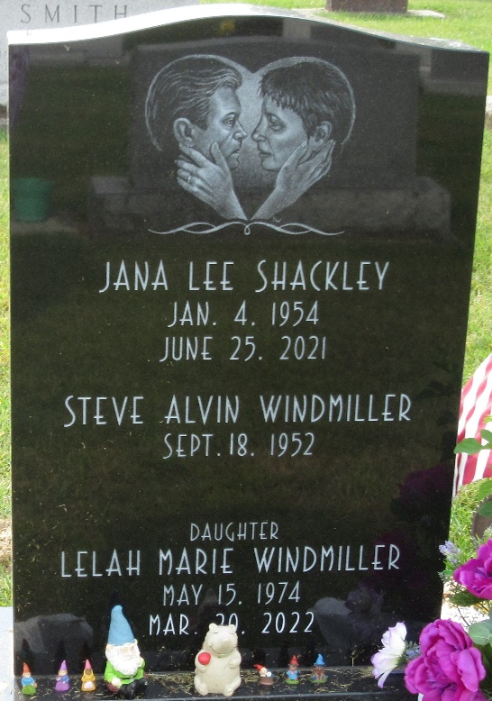
Photo by PLS
Lelah M. Windmiller, 47, of Decatur, IN passed away on Sunday, March 20, 2022 at Parkview Regional Medical Center. Lelah was born on May 15, 1974 in Decatur, IN.
Lelah worked as an associate for Wal-Mart for 15 years. She was a 1992 graduate of Bellmont High School. She was in the Explorers and Lions Club in Pleasant Mills.
She was a bright light that went out too soon. She had a great sense of humor and always made everybody feel like a friend.
Lelah is survived by her father of Decatur; many extended family members; many, many friends; her two cats, Georgette and Don.
She was preceded in death by her mother Jana L. Shackley on June 25, 2021; her aunt, Lori Shackley and uncle, Dan McAtee; grandparents, Jim and Betty Shackley, Don and Ruby Windmiller, and Theodore and Alvera Eady.
Visitation will be from 4:00 – 7:00 p.m. on Monday, March 28, 2022 at Haggard-Sefton-Hirschy & Zelt Funeral Home. Burial will take place in the Decatur Cemetery at a later date.

Haggard & Sefton Funeral Home, Adams County, Indiana
March 21, 2022

