Donald Wayne Windmiller
September 5, 1923 – May 2, 1992

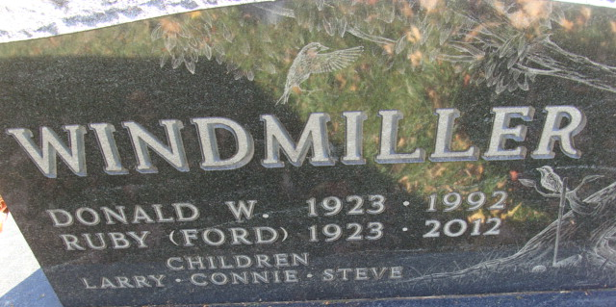
Photo by Alicia Kneuss
Donald W Windmiller
in the Indiana, U.S., Death Certificates, 1899-2017

Name Donald W Windmiller
Gender Male
Race White
Marital Status Married
Age 68
Birth Date 5 Sep 1923
Birth Place Adams County, Indiana
Death Date 2 May 1992
Death Place Fort Wayne, Allen, Indiana, USA
Death Registration Date 1992
Father Alvin H Windmiller
Mother Nola F Schaupp
Spouse Ruby E Ford
Informant Ruby E. Windmiller; wife; Decatur, Indiana
Burial May 5, 1992; Decatur Cemetery; Decatur, Indiana

